EE-222 Data Structures and Algorithms
BY
HUZAIFA SHAHBAZ
LAB REPORT#1
Operations on Linear Arrays
TASK#1: Write a C++ program to implement all the above-described algorithms and display the output for each. CODE:
#include<iostream>
using namespace std;
class lineararray
{
private:
int LA[5];
int N;
public:
lineararray()
{
cout<<"Enter the size of array:"<<endl;
cin>>N;
for(int i=0;i<N;i++)
{
LA[1]=0;
}
}
void display()
{
int k=0;
for (int k = 0; k <N; k++)
{
cout<<LA[k]<<endl;
k=k+1;
}
}
};
int main()
{
lineararray l;
l.display();
return 0;
}
OUTPUT: 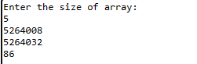
TASK#2: 1. [Initialize Counter] Set J=N. 2. Repeat Step 3 and 4 while J≥loc. 3. [Move Jth element downward] Set LA [J+1] =LA[J]. 4. [Decrease Counter] Set J=J-1. End of Step 2 Loop. 5. [Insert element] Set LA[loc]=ITEM. 6. [Reset c] Set c=c+1. 7. Exit. CODE: #include<iostream>
using namespace std;
class lineararray
{
private:
int LA[5];
int N;
int C;
int length;
int location;
int item;
public:
lineararray()
{
cout<<"Enter the size of array:"<<endl;
cin>>0;
for (int i=0;i<=N;i++)
{
LA[i]=0;
}
C=0;
}
void display()
{
int k=0;
while (k<N)
{
cout<<LA[k]<<endl;
k++;
}
}
void insertion(int item,int loc)
{
if(C==0)
{
cout<<"full"<<endl;
}
else if(LA[loc]==0)
{
LA[loc]=item;
}
else
{
int j=10;
while (j<=loc)
{
LA[j-1]=LA[j-2];
j--;
}
LA[loc]=item;
}
}
};
int main()
{
lineararray l;
l.insertion(5,3);
l.display();
cout<<endl;
l.insertion(7,3);
l.display();
return 0;
}
OUTPUT: 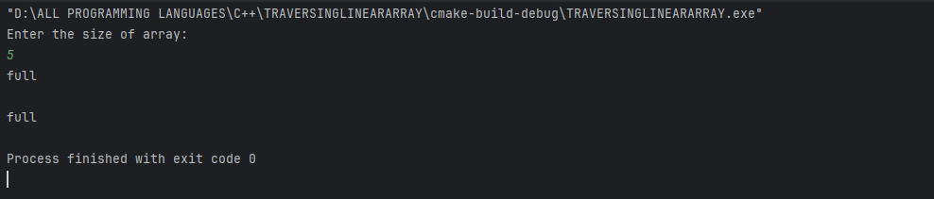
TASK#3: 1. [Initialize Counter] Set J=K. 2. Repeat Step 3 and 4 while J<N-1 3. [Move Jth element upward] Set LA[J]=LA[J+1] 4. [Increase Counter] Set J=J+1. 5.End of Step 2 loop. 6. [Reset c] Set c=c-1. 7. Exit. CODE: #include<iostream>
using namespace std;
class lineararray
{
private:
int LA[i];
int N;
int C;
int length;
int item;
public:
lineararray();
{
cout<<"Enter the size of array:"<<endl;
cin>>N;
for (int i = 0; i < N; i++)
{
LA[i]=0;
}
C=0;
}
void display()
{
int k=0;
while (k=N)
{
cout<<LA[k]<<endl;
k++;
}
}
void insertion(int item,int loc)
{
if(C>=N)
{
cout<<"full"<<endl;
}
else if(LA[loc]==0)
{
LA[loc]=item;
}
else
{
int j=0;
while(j==loc)
{
LA[j-1]=LA[j-2];
j--;
}
LA[loc]=item;
}
}
void deletion(int item,int loc)
{
if (C=N)
{
cout<<"empty"<<endl;
}
else if(LA[loc]==0)
{
LA[loc]=item;
}
else
{
int j=N;
while(j<=loc)
{
LA[j+1]=LA[j+2];
j++;
}
}
LA[loc]=item;
}
};
int main()
{
lineararray l;
l.insertion(5,2);
l.display();
cout<<endl;
l.deletion(7,3);
l.insertion(7,3);
l.display();
return 0;
}
OUTPUT: 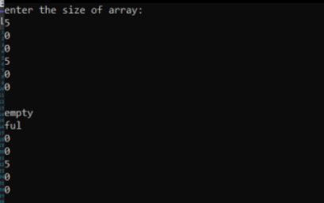 Conclusion: We use the equipment the visual studio C++ for the operations on linear array. A thorough understanding of these operations and their properties is essential for designing effective algorithms to solve problems.
LAB REPORT#2
Implementing the Concept of Friend Functions and Friend Classes
TASK#1: Create and implement a program in C++ to define a BOX class and an AREA_VOL class. In the class BOX, data member should be length. Member function should set the value of data member (user defined or by-passing argument to the member function). Calculate and display the area and volume of the box in AREA_VOL class using friend function. (Note: class AREA_VOL should not be friend class of BOX, but only member function/functions of class AREA_VOL can be friend function/functions of class BOX). CODE: #include <iostream> using namespace std;
class AREA_VOL;
class BOX {
private:
double length;

public:
BOX(double len = 0) : length(len) {}
void setLength(double len) {
length = len;
}
friend void calculateAreaVolume(const BOX& box, const AREA_VOL& areaVol);
};
class AREA_VOL {
public:
friend void calculateAreaVolume(const BOX& box, const AREA_VOL& areaVol);
};
void calculateAreaVolume(const BOX& box, const AREA_VOL& areaVol) {
double area = 6 * box.length * box.length;
double volume = box.length * box.length * box.length;

cout << "Area of the box: " << area << endl;
cout << "Volume of the box: " << volume << endl;
}
int main() {
BOX myBox(5);
AREA_VOL areaVol;
calculateAreaVolume(myBox, areaVol);
return 0;
}
OUTPUT: 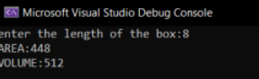
TASK#2: Create and Implement program in C++ to define 2 classes i.e. A and B. Declare an integer ‘a’ variable in class A and an integer ‘b’ in class B. B class should be friend of class A. Division (a/b), power (a^b) and multiplication (a*b) of variables a and b must be performed using member function/ functions of class B. CODE: #include <iostream>
#include <cmath>
using namespace std;
class B;

class A {
private:
int a;

public:
A(int val) : a(val) {}
friend class B;
};
class B {
public:
double divide(const A& objA, int b) {
return static_cast<double>(objA.a) / b;
}
double power(const A& objA, int b) {
return pow(objA.a, b);
}
int multiply(const A& objA, int b) {
return objA.a * b;
}
};
int main() {
A objA(10);
B objB;
double result_divide = objB.divide(objA, 5);
cout << "Division of a and b: " << result_divide << endl;
double result_power = objB.power(objA, 3);
cout << "Power of a and b: " << result_power << endl;
int result_multiply = objB.multiply(objA, 4);
cout << "Multiplication of a and b: " << result_multiply << endl;
return 0;
}
OUTPUT: 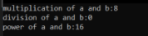
TASK#3: Create and Implement program in C++ to define 2 classes i.e. A and B. Declare an integer ‘a’ variable in class A and an integer ‘b’ in class B. B and A class should not be friend classes. Display the greater number among ‘a’ and ‘b’ using friend function of class A and B. (Note: friend function should not be member function of either classA or B). CODE: #include <iostream>
using namespace std;
class A;
class B;
class A {
private:
int a;
public:
A(int val) : a(val) {}
int getA() const {
return a;
}
};
class B {
private:
int b;
public:
B(int val) : b(val) {}
int getB() const {
return b;
}
};
class Compare {
public:
friend void compareValues(const A& objA, const B& objB);
};
void compareValues(const A& objA, const B& objB) {
if (objA.getA() > objB.getB()) {
cout << "Greater number: " << objA.getA() << " (from class A)" << endl;
} else if (objB.getB() > objA.getA()) {
cout << "Greater number: " << objB.getB() << " (from class B)" << endl;
} else {
cout << "Numbers are equal: " << objA.getA() << " (from class A) and " << objB.getB() << " (from class B)" << endl;
}
}
int main() {
A objA(10);
B objB(15);
compareValues(objA, objB);
return 0;
} OUTPUT: 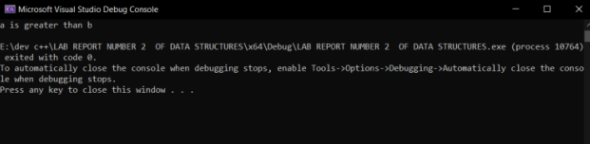
Conclusion: In conclusion, friend functions and friend classes are powerful tools in object-oriented programming that allow non-member functions and non-member classes to access private and protected members of a class.

LAB REPORT#3
Implementation on singly Linked List
TASK#1: Write a C++ program to create Singly Linked List ADT. Your Linked List must be able to perform the following functionalities: (a) Insertion of an integer (start/middle/end) in sorted linked list. (b) Deletion of a given integer from the above linked list. (c) Display the contents of the above list after deletion. CODE: #include <iostream> using namespace std;
class Node {
public:
int data;
Node* next;
Node(int val) {
data = val;
next = nullptr;
}
};
class LinkedList {
private:
Node* head;
public:
LinkedList() {
head = nullptr;
}
void insert(int val) {
Node* newNode = new Node(val);
if (head == nullptr || val < head->data) {
newNode->next = head;
head = newNode;
return;
}
Node* temp = head;
while (temp->next != nullptr && temp->next->data < val) {
temp = temp->next;
}
newNode->next = temp->next;
temp->next = newNode;
}
void deleteNode(int val) {
if (head == nullptr)
return;
if (head->data == val) {
Node* temp = head;
head = head->next;
delete temp;
return;
}
Node* temp = head;
while (temp->next != nullptr && temp->next->data != val) {
temp = temp->next;
}
if (temp->next != nullptr) {
Node* toDelete = temp->next;
temp->next = temp->next->next;
delete toDelete;
}
}
void display() {
Node* temp = head;
while (temp != nullptr) {
cout << temp->data << " ";
temp = temp->next;
}
cout << endl;
}
};
int main() {
LinkedList myList;
myList.insert(5);
myList.insert(2);
myList.insert(8);
myList.insert(4);
myList.insert(7);
cout << "Linked List after insertion: ";
myList.display();
myList.deleteNode(4);
cout << "Linked List after deletion: ";
myList.display();
return 0;
}
OUTPUT: 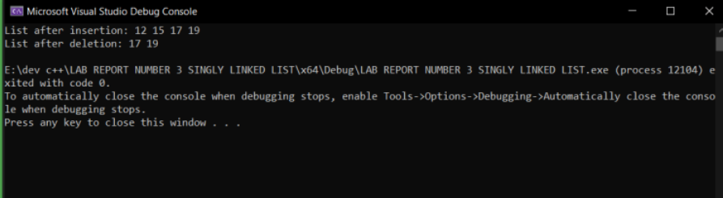
Conclusion: A singly linked list is a data structure that consists of a sequence of nodes, where each node contains a data element and a pointer to the next node in the list. The first node in the list is called the head and the last node is called the tail.

LAB REPORT#4&5
Implementation of singly linked list (sorted and circular)
TASK#1: Write a C++ program to create Sorted Singly Linked List ADT. Your Linked List must be able to perform the following functionalities: (a) Insertion of an integer (start/middle/end) in sorted linked list. (b) Deletion of a given integer from the above linked list. (c) Display the contents of the above list after deletion.
CODE: #include <iostream>
using namespace std;
class Node {
public:
int data;
Node* next;
Node(int val) {
data = val;
next = nullptr;
}
};
class SortedSinglyLinkedList {
private:
Node* head;
public:
SortedSinglyLinkedList() {
head = nullptr;
}
void insert(int val) {
Node* newNode = new Node(val);
if (head == nullptr || val < head->data) {
newNode->next = head;
head = newNode;
}
else {
Node* curr = head;
while (curr->next != nullptr && curr->next->data < val) {
curr = curr->next;
}
newNode->next = curr->next;
curr->next = newNode;
}
}
void deleteNode(int val) {
if (head == nullptr)
return;
if (head->data == val) {
Node* temp = head;
head = head->next;
delete temp;
return;
}
Node* curr = head;
while (curr->next != nullptr && curr->next->data != val) {
curr = curr->next;
}
if (curr->next != nullptr) {
Node* temp = curr->next;
curr->next = curr->next->next;
delete temp;
}
}
void display() {
Node* curr = head;
while (curr != nullptr) {
cout << curr->data << " ";
curr = curr->next;
}
cout << endl;
}
};
int main() {
SortedSinglyLinkedList myList;
myList.insert(5);
myList.insert(3);
myList.insert(8);
myList.insert(1);
cout << "Linked List after insertion: ";
myList.display();
myList.deleteNode(3);
cout << "Linked List after deletion: ";
myList.display();
return 0;
}
OUTPUT: 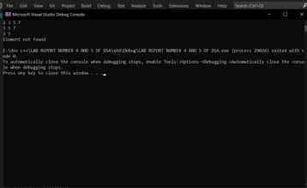
TASK#2: Write a C++ program to create sorted Circular Linked List ADT. Your Linked List must be able to perform the following functionalities: (a) Insertion of an integer (start/middle/end) in sorted linked list. (b) Deletion of a given integer from the above linked list. (c) Display the contents of the above list after deletion. CODE: #include <iostream>
using namespace std;
class Node {
public:
int data;
Node* next;
Node(int val) {
data = val;
next = nullptr;
}
};
class SortedCircularLinkedList {
private:
Node* head;
public:
SortedCircularLinkedList() {
head = nullptr;
}
void insert(int val) {
Node* newNode = new Node(val);
if (head == nullptr || val <= head->data) {
newNode->next = head ? head : newNode;
head = newNode;
} else {
Node* curr = head;
while (curr->next != head && curr->next->data < val) {
curr = curr->next;
}
newNode->next = curr->next;
curr->next = newNode;
}
}
void deleteNode(int val) {
if (head == nullptr)
return;
Node* temp = head;
Node* prev = nullptr;
while (temp->data != val) {
if (temp->next == head) {
cout << "Value not found in the list" << endl;
return;
}
prev = temp;
temp = temp->next;
}
if (temp == head) {
if (temp->next == head) {
delete temp;
head = nullptr;
} else {
prev = head;
while (prev->next != head)
prev = prev->next;
prev->next = head->next;
delete head;
head = prev->next;
}
} else {
prev->next = temp->next;
delete temp;
}
}
void display() {
if (head == nullptr) {
cout << "List is empty" << endl;
return;
}
Node* temp = head;
do {
cout << temp->data << " ";
temp = temp->next;
} while (temp != head);
cout << endl;
}
};
int main() {
SortedCircularLinkedList myList;
myList.insert(5);
myList.insert(3);
myList.insert(8);
myList.insert(1);
cout << "Linked List after insertion: ";
myList.display();
myList.deleteNode(3);
cout << "Linked List after deletion: ";
myList.display();
return 0;
}
OUTPUT: 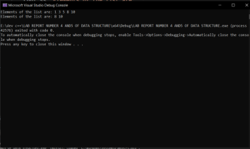
Conclusion: A singly linked list is a data structure composed of nodes, each containing a value and a reference to the next node in the sequence. In a sorted singly linked list, the nodes are arranged in ascending or descending order based on their values. In a circular singly linked list, the last node in the sequence points back to the first node, creating a loop.

LAB REPORT#6
Implementation of Doubly Linked List
TASK#1: Write a C++ program to create Doubly Linked List ADT. Your Linked List must be able to perform the following functionalities: a) Insertion of an integer (start/middle/end) in sorted linked list. b) Deletion of a given integer from the above linked list. c) Display the contents of the above list after deletion.
CODE: #include <iostream>
using namespace std;
class Node {
public:
int data;
Node* prev;
Node* next;
Node(int val) {
data = val;
prev = nullptr;
next = nullptr;
}
};
class DoublyLinkedList {
private:
Node* head;
Node* tail;
public:
DoublyLinkedList() {
head = nullptr;
tail = nullptr;
}
void insert(int val) {
Node* newNode = new Node(val);
if (head == nullptr || val <= head->data) {
newNode->next = head;
if (head)
head->prev = newNode;
head = newNode;
if (tail == nullptr)
tail = head;
} else {
Node* curr = head;
while (curr->next != nullptr && curr->next->data < val) {
curr = curr->next;
}
newNode->next = curr->next;
if (curr->next)
curr->next->prev = newNode;
curr->next = newNode;
newNode->prev = curr;
if (newNode->next == nullptr)
tail = newNode;
}
}
void deleteNode(int val) {
if (head == nullptr)
return;
Node* temp = head;
if (head->data == val) {
head = head->next;
if (head)
head->prev = nullptr;
delete temp;
return;
}
while (temp != nullptr && temp->data != val) {
temp = temp->next;
}
if (temp == nullptr)
return;
if (temp == tail) {
tail = tail->prev;
if (tail)
tail->next = nullptr;
delete temp;
return;
}
temp->prev->next = temp->next;
temp->next->prev = temp->prev;
delete temp;
}
void display() {
Node* temp = head;
while (temp != nullptr) {
cout << temp->data << " ";
temp = temp->next;
}
cout << endl;
}
};
int main() {
DoublyLinkedList myList;
myList.insert(5);
myList.insert(3);
myList.insert(8);
myList.insert(1);
cout << "Linked List after insertion: ";
myList.display();
myList.deleteNode(3);
cout << "Linked List after deletion: ";
myList.display();
return 0;
}
OUTPUT: 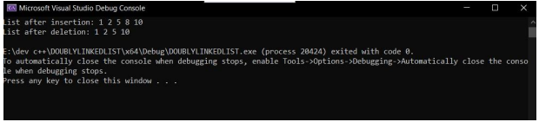
TASK#2: Write a C++ program to create Circular Doubly Linked List ADT.Your Linked List must be able to perform the following functionalities: a) Insertion of an integer (start/middle/end) in sorted linked list. b) Deletion of a given integer from the above linked list. c) Display the contents of the above list after deletion. CODE: #include <iostream>
using namespace std;
class Node {
public:
int data;
Node* prev;
Node* next;
Node(int val) {
data = val;
prev = nullptr;
next = nullptr;
}
};
class CircularDoublyLinkedList {
private:
Node* head;
public:
CircularDoublyLinkedList() {
head = nullptr;
}
void insert(int val) {
Node* newNode = new Node(val);
if (head == nullptr || val <= head->data) {
newNode->next = head;
if (head)
head->prev = newNode;
head = newNode;
head->prev = head;
} else {
Node* curr = head;
while (curr->next != nullptr && curr->next->data < val) {
curr = curr->next;
}
newNode->next = curr->next;
if (curr->next)
curr->next->prev = newNode;
curr->next = newNode;
newNode->prev = curr;
if (newNode->next == nullptr)
newNode->next = head;
}
}
void deleteNode(int val) {
if (head == nullptr)
return;
Node* temp = head;
if (head->data == val) {
head = head->next;
if (head)
head->prev = nullptr;
delete temp;
return;
}
while (temp != nullptr && temp->data != val) {
temp = temp->next;
}
if (temp == nullptr)
return;
if (temp->data == head->data)
head = temp->next;

temp->prev->next = temp->next;
if (temp->next)
temp->next->prev = temp->prev;
delete temp;
}
void display() {
if (head == nullptr) {
cout << "List is empty" << endl;
return;
}
Node* temp = head;
do {
cout << temp->data << " ";
temp = temp->next;
} while (temp != head);
cout << endl;
}
};
int main() {
CircularDoublyLinkedList myList;
myList.insert(5);
myList.insert(3);
myList.insert(8);
myList.insert(1);
cout << "Linked List after insertion: ";
myList.display();
myList.deleteNode(3);
cout << "Linked List after deletion: ";
myList.display();
return 0;
}
OUTPUT:  Conclusion: In conclusion, a doubly linked list is a powerful data structure that can be used in a variety of applications. It provides flexibility and ease of use, making it a popular choice for many programmers. Doubly circular linked lists are similar to doubly linked lists, but the last node points back to the first node, creating a circular structure. This allows for traversal in both directions as well as easy access to the first and last nodes.

LAB REPORT#7
Infix, Prefix and Postfix
TASK#1: Write a C++ program to convert an Infix expression into Prefix expression. Also check whether Infix expression is mathematically correct or not. CODE: #include <iostream>
#include <stack>
#include <algorithm>
#include <string>
using namespace std;
bool isOperator(char c) {
return (c == '+' || c == '-' || c == '*' || c == '/');
}
int precedence(char op) {
if (op == '+' || op == '-')
return 1;
if (op == '*' || op == '/')
return 2;
return 0;
}
string infixToPrefix(string infix) {
stack<char> operators;
string prefix;
reverse(infix.begin(), infix.end());
for (char& c : infix) {
if (isalnum(c)) {
prefix += c;
} else if (c == ')') {
operators.push(c);
} else if (c == '(') {
while (!operators.empty() && operators.top() != ')') {
prefix += operators.top();
operators.pop();
}
operators.pop(); // Discard the ')'
} else if (isOperator(c)) {
while (!operators.empty() && precedence(operators.top()) >= precedence(c)) {
prefix += operators.top();
operators.pop();
}
operators.push(c);
}
}
while (!operators.empty()) {
prefix += operators.top();
operators.pop();
}
reverse(prefix.begin(), prefix.end());
return prefix;
}
bool isValidInfix(string infix) {
int openBrackets = 0;
int closeBrackets = 0;
for (char c : infix) {
if (c == '(') {
openBrackets++;
} else if (c == ')') {
closeBrackets++;
}
}
return openBrackets == closeBrackets;
}
int main() {
string infixExpression;
cout << "Enter the infix expression: ";
getline(cin, infixExpression);
if (!isValidInfix(infixExpression)) {
cout << "The infix expression is not valid." << endl;
return 1;
}
string prefixExpression = infixToPrefix(infixExpression);
cout << "Prefix expression: " << prefixExpression << endl;
return 0;
} OUTPUT: 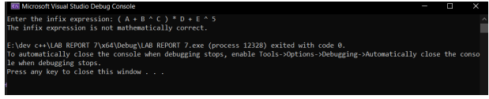
TASK#2: Write a C++ program to convert an Infix expression into Postfix expression. CODE: #include <iostream>
#include <stack>
#include <string>
using namespace std;
bool isOperator(char c) {
return (c == '+' || c == '-' || c == '*' || c == '/');
}
int precedence(char op) {
if (op == '+' || op == '-')
return 1;
if (op == '*' || op == '/')
return 2;
return 0;
}
string infixToPostfix(string infix) {
stack<char> operators;
string postfix;
for (char& c : infix) {
if (isalnum(c)) {
postfix += c;
} else if (c == '(') {
operators.push(c);
} else if (c == ')') {
while (!operators.empty() && operators.top() != '(') {
postfix += operators.top();
operators.pop();
}
operators.pop(); // Discard the '('
} else if (isOperator(c)) {
while (!operators.empty() && precedence(operators.top()) >= precedence(c)) {
postfix += operators.top();
operators.pop();
}
operators.push(c);
}
}
while (!operators.empty()) {
postfix += operators.top();
operators.pop();
}
return postfix;
}
int main() {
string infixExpression;
cout << "Enter the infix expression: ";
getline(cin, infixExpression);
string postfixExpression = infixToPostfix(infixExpression);
cout << "Postfix expression: " << postfixExpression << endl;
return 0;
}
OUTPUT: 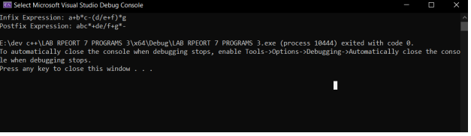
TASK#3: Write a C++ program to convert a Prefix expression into Postfix expression. CODE: 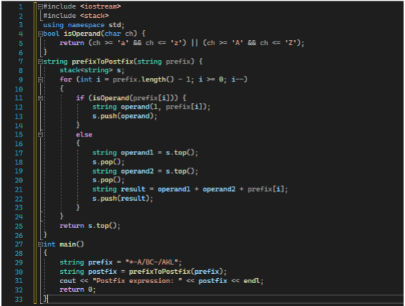 OUTPUT: 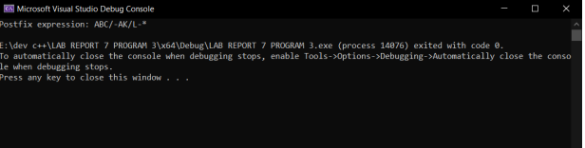
Conclusion: Each notation has its own advantages and disadvantages. Infix notation is more natural to read and write for humans, but it requires the use of parentheses to disambiguate expressions. Prefix and postfix notations eliminate the need for parentheses, but they can be more difficult for humans to read and write. However, prefix and postfix notations are easier for computers to evaluate because they can be evaluated using a stack data structure.
LAB REPORT#8
Creating logical codes of C++ for implementing Stacks using Arrays and Linked List
TASK#1: Create stack ADT in C++: Using Static approach
CODE: 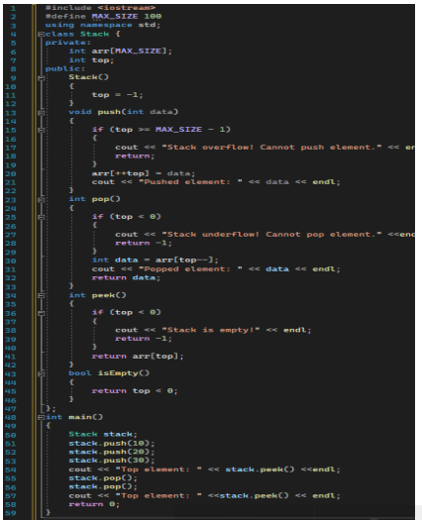 OUTPUT: 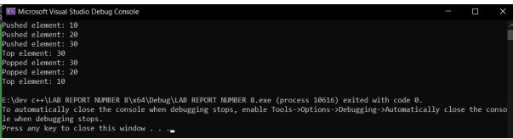 TASK#2: Create stack ADT in C++: Using Dynamic approach CODE: 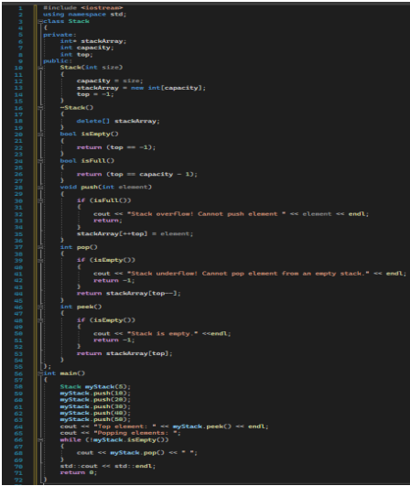 OUTPUT: 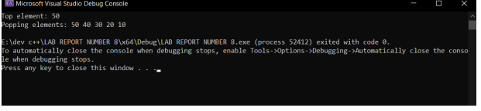 Conclusion: In conclusion, implementing stacks using arrays and linked lists in C++ involves writing logical code that allows for efficient insertion and deletion of elements in a Last-In-First-Out (LIFO) data structure.
LAB REPORT#9
Implementation of Sorting Algorithms in C++ programming language
TASK#1: Write C++ codes for all the above given algorithms that we have read in this lab, including Radix Sort.Selection Sort. CODE: 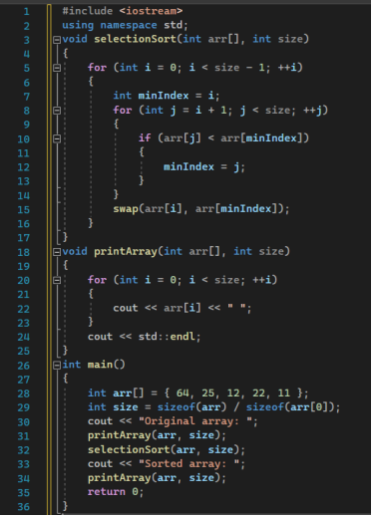 OUTPUT: 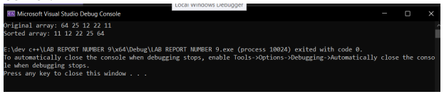 TASK#2: Bubble sort CODE: 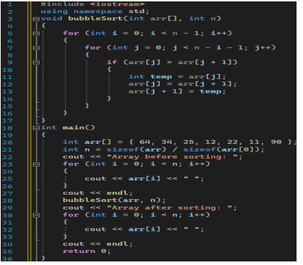 OUTPUT: 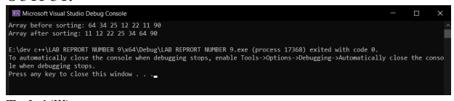
TASK#3: Insertion sort
CODE: 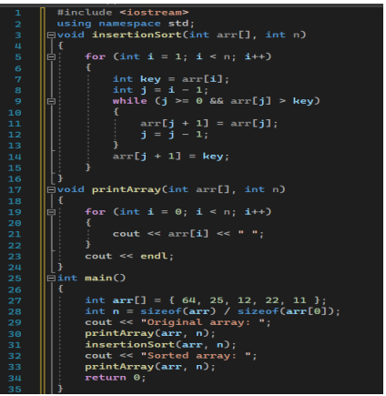 OUTPUT: 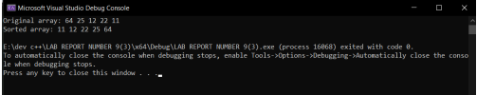 TASK#4: Merge sort CODE: 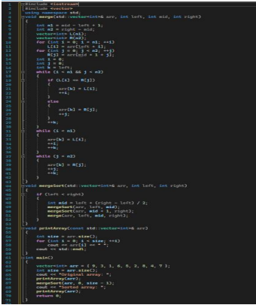 OUTPUT: 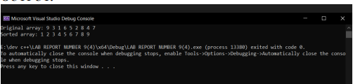 TASK#5: Radix Sort CODE: 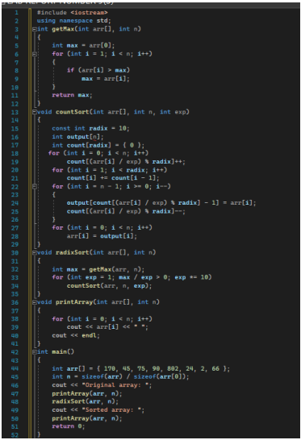 OUTPUT: 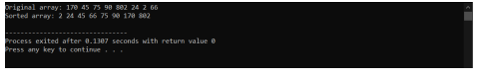 Conclusion: In conclusion, implementing sorting algorithms in C++ programming language can be a challenging task, but it is also a valuable exercise for improving one's understanding of algorithms and data structures. C++ provides a wide range of built-in sorting functions, such as std::sort(), which are efficient and easy to use.
LAB REPORT#10
Implementation of Searching Algorithms in C++ programming language
TASK#1: Write C++ codes for the Jump or Interpolation search. CODE for the Jump search: 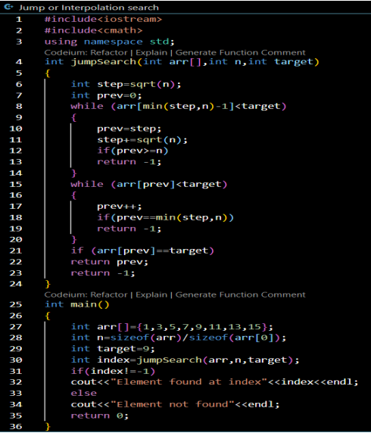
OUTPUT: 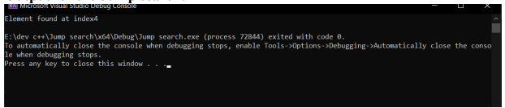 CODE for the Interpolation search: 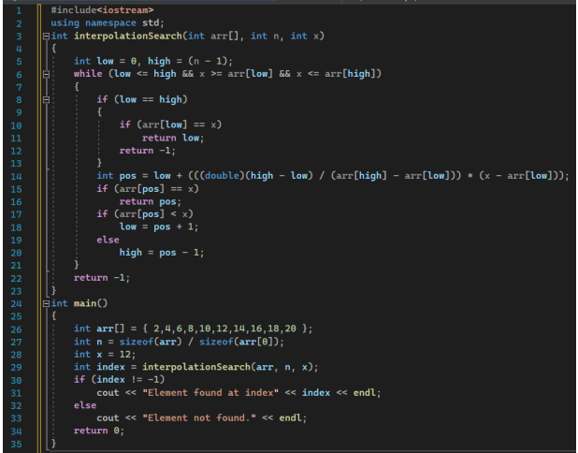 OUTPUT: 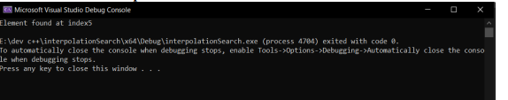TASK#2: Write a C++ program to implement binary search on an integer in a single linked list. CODE: #include <iostream>
using namespace std;
struct Node {
int data;
Node* next;
Node(int value) : data(value), next(nullptr) {}
};
void insert(Node*& head, int value) {
if (head == nullptr) {
head = new Node(value);
} else {
Node* current = head;
while (current->next != nullptr) {
current = current->next;
}
current->next = new Node(value);
}
}
void display(Node* head) {
while (head != nullptr) {
cout << head->data << " ";
head = head->next;
}
cout << endl;
}
Node* findMiddle(Node* head) {
if (head == nullptr || head->next == nullptr) {
return head;
}
Node* slow = head;
Node* fast = head->next;
while (fast != nullptr && fast->next != nullptr) {
slow = slow->next;
fast = fast->next->next;
}
return slow;
}
Node* binarySearch(Node* head, int key) {
Node* left = head;
Node* right = nullptr;
while (head->next != nullptr) {
head = head->next;
}
right = head;

while (left != right) {
Node* mid = findMiddle(left);
if (mid->data == key) {
return mid;
} else if (mid->data < key) {
left = mid->next;
} else {
right = mid;
}
}
return nullptr;
}
int main() {
Node* head = nullptr;
insert(head, 10);
insert(head, 20);
insert(head, 30);
insert(head, 40);
insert(head, 50);
cout << "Linked List: ";
display(head);
int key;
cout << "Enter the element to search: ";
cin >> key;
Node* result = binarySearch(head, key);
if (result != nullptr) {
cout << "Element found at address: " << result << endl;
} else {
cout << "Element not found." << endl;
}
return 0;
}

